**Food Connect**

**1.Project Overview:**

 The objective of a project  "Food Connect" app is aimed at serving food to those in need. The primary goal of the project is to address the widespread problem of hunger and food insecurity by ensuring that underserved communities, including low-income families, the homeless, and migrant workers, have access to nutritious food. The goal is to deliver a comprehensive solution by leveraging the sales force technology. Through this project, we aim to enhance the ecofriendly experience to the users and have easy access to the app and support the long-term goals of the food connect app.

**2.Objectives:**

* Provide Nutritious Meals to Vulnerable Communities: To serve healthy, balanced meals to economically disadvantaged individuals, such as low-income families, the homeless, elderly citizens, and migrant workers across Andhra Pradesh.
* Reduce Food Waste in the Region: To collect surplus or excess food from restaurants, hotels, and food outlets in Andhra Pradesh and redistribute it to those in need, helping reduce food wastage in the region.
* Promote Food Security and Nutrition: To address food insecurity by ensuring the availability of regular, nutritious meals to communities struggling with hunger, and educating them about proper nutrition.
* Support Local Farmers and Producers: To collaborate with local farmers and food producers to purchase fresh, locally grown food and provide it to communities, strengthening local agriculture and the economy.
* Create Sustainable Food Distribution Systems: To establish a network of food distribution channels that can efficiently and sustainably reach those in need, especially in rural areas and underserved urban communities.
* Encourage Community Engagement and Volunteerism: To involve the people of Andhra Pradesh in tackling hunger by organizing food drives, volunteer activities, and community kitchens, creating a sense of solidarity and social responsibility.
* Emergency Food Assistance During Crisis: To provide food aid during natural disasters, public health emergencies, or other situations that lead to short-term food insecurity across Andhra Pradesh.
* Raise Awareness About Hunger and Malnutrition: To increase public awareness about food insecurity and malnutrition, highlighting the importance of sustainable solutions to address these issues on a broader scale.
* Promote Partnerships with NGOs and Government: To work with local government bodies, NGOs, and other stakeholders in Andhra Pradesh to increase the reach and effectiveness of food distribution programs and ensure comprehensive support.
* Establish Long-Term Solutions to Combat Hunger: To implement programs that not only offer immediate relief but also develop long-term strategies for reducing food insecurity, such as food banks, community gardens, and skill-building programs related to food sustainability.

**3. Salesforce Key Features and Concepts Utilized**

In the context of a Food Connect app, which could be designed to facilitate food distribution, manage donations, and connect volunteers or food donors to people in need, Salesforce provides various tools and concepts that could be leveraged to streamline and optimize its operations. Here are key Salesforce features and concepts that could be utilized in the Food Connect app:

1. Salesforce CRM (Customer Relationship Management)

* Managing Volunteer: The app could use Salesforce CRM to track and manage relationships with  volunteers, and food recipients. For example, you can create profiles for donors, track their donations, and communicate with them efficiently.
* Donor Engagement: Use Salesforce's automation tools to send personalized thank-you messages, updates about how their donations have helped, and reminders about future opportunities to donate.

2. Salesforce Communities (Experience Cloud)

* **Volunteer Portal**: Salesforce’s Experience Cloud allows the creation of online communities. A volunteer portal can be set up for individuals to sign up for shifts, check their schedules, and track hours worked.
* **Food Recipient Portal**: A separate community can be built for food recipients to register for services, request meals, or check the availability of food distribution points, enhancing transparency and communication.

3. Salesforce Flow

* **Automation of Tasks**: Salesforce Flow can automate various process such as sending notifications to food donors when their contribution is received, reminding volunteers of their upcoming shifts, or notifying food distribution centers when stock is low.
* **Approval Processes**: If there is a need for approval (for example, validating large food donations), Salesforce Flow can automate this process to ensure everything is approved in a timely manner.

4. Salesforce Reports & Dashboards

* **Tracking Impact**: The app can generate **real-time reports** and **dashboards** to track key metrics such as total meals served, donations received, volunteer hours, and the geographical reach of food distribution. This helps in assessing the performance and improving the project.
* **Data-Driven Insights**: By leveraging Salesforce’s powerful analytics tools, Food Connect can gain insights into donation patterns, identify areas with higher demand for food, and optimize their outreach efforts.

5. Salesforce Mobile Application

* **Mobile Accessibility**: The **Salesforce mobile app** allows users (both volunteers and food recipients) to access the platform on the go. Volunteers can log their hours, check their schedule, and update their availability, while recipients can register for services, view nearby distribution points, or provide feedback.

6. Salesforce Integration with Payment Gateways

**Easy Donations**: Integrating payment systems like PayPal or Stripe within the app can allow users to make monetary donations securely. These donations can then be tracked, processed, and reported using Salesforce.

**4.Detailed Steps to Solution Design**

Designing a solution for Food Connect app in the salesforce requires a structured approach that levarages Salesforce's platform features, such as salesforce app cloud salesforce service cloud, and salesforce Marketing cloud. Here is a detailed step by step approach to designing the solution for a food sharing of dood related application in salesforce:

**1. Understanding the Requirements:**

Before diving into design, fully understand the business requirements for the Food Connect app. Key questions to address:

* What is the core purpose of the app (e.g., food donation, food sharing, delivery.
* Who are the primary users (donors, recipients, volunteers, administrators)?
* What are the specific features needed (e.g., real-time matching, geolocation, notifications, inventory tracking)?
* How will the system interact with external systems (e.g., payment systems, inventory systems, etc.

**2. Identify Key Entities (Data Model)**

The first step in designing any solution is to identify the data entities (objects) that the app will use. For a Food Connect app, consider:

* **User Profile**: Recipient, Volunteer
  + User information such as name, contact details, role (donor, recipient, volunteer), address, preferences, etc.
  + Integration with Salesforce User and Profile objects for access control and permissions.

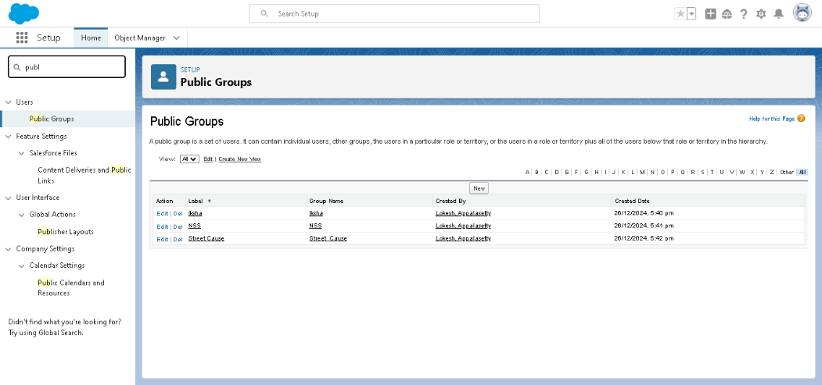

* **Food Donation**: Represents food items donated.
  + Fields might include type of food, expiration date, quantity, donor details, recipient details, status (pending, delivered, etc.).
* **Food Request**: Represents a recipient’s request for food.
  + Fields include the type of food, quantity needed, location, urgency, and recipient information.
* **Inventory Management**: To track food stock and availability.
  + Fields like food type, quantity available, status, and location.
* **Delivery/Distribution**: Represents food distribution to the recipient.
  + Information about delivery status, delivery date, volunteer involvement.
* **Geolocation Data**: Mapping features to track the location of donors, recipients, and food warehouses. Integration with mapping services (like Google Maps or Salesforce Maps).
* **Event/Alerts**: Notifications to users when new food requests are posted, when a food donation is available, or when food is about to expire.

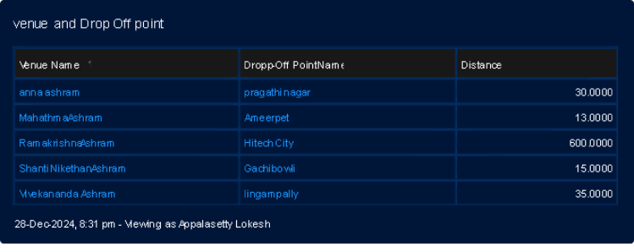

**3. Define the User Experience (UX)**

Design how different users (donors, recipients, volunteers) will interact with the app. This can be achieved through:

* **Salesforce Lightning Experience**: Use Salesforce Lightning components to create a custom interface that is responsive and user-friendly.
* **Mobile-Friendly Design**: Salesforce mobile app allows users to access the app on mobile devices, which is essential for real-time updates.
* **Custom Salesforce Pages**: Create custom Lightning pages for different user profiles, e.g., Donor’s Dashboard, Recipient’s Dashboard, Volunteer tasks, etc.

**4. Design the Business Logic**

The business logic drives how the app behaves. This can be implemented using Salesforce features such as:

* **Apex Code**: Write custom logic using Apex classes and triggers to manage complex actions like:
  + Matching food donations with recipient requests.
  + Automating notifications when a new request or donation is made.
  + Validating the expiration dates of food items.

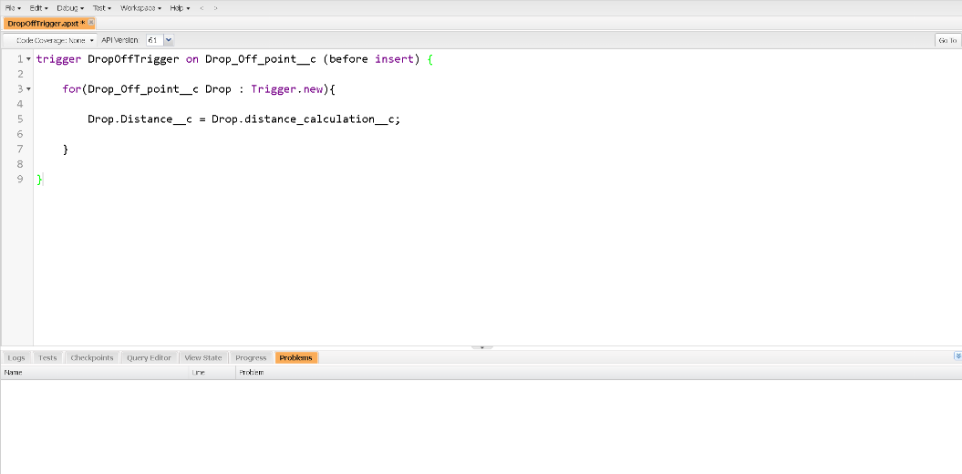

* **Process Builder**: Automate workflows such as:
  + Sending an email alert when a donation is matched with a recipient.
  + Automatically updating the status of the donation request after food is delivered.
* **Flow Builder**: Create user-driven flows  to guide users through tasks such as donating food or requesting food.
* **Validation Rules**: Ensure that data entered into the system is accurate (e.g., preventing expired food from being donated, ensuring donors provide required info).
* **Custom Lightning Web Components (LWC)**: Develop custom components for advanced UI features, like real-time location tracking or food matching.

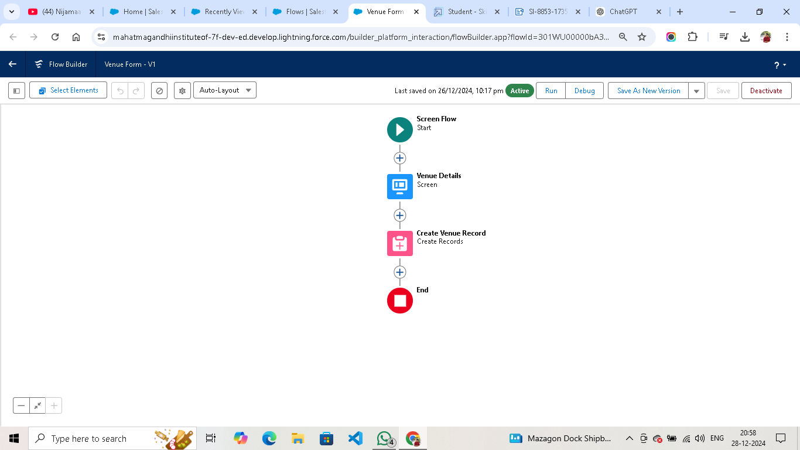

**6. Security and Permissions**

Secure the app by defining appropriate security measures:

* **Role-Based Access Control**: Set up user profiles and roles to ensure that donors, recipients, and volunteers only see what they need to see. Use Salesforce’s Role and Profile hierarchy.
* **Sharing Rules**: Define sharing rules for data visibility (e.g., donors should not see other donors' information).
* **Field-Level Security**: Limit access to sensitive data (e.g., contact information) based on the user’s role.

**7. Analytics and Reporting**

To track the app’s performance and understand user activity, use Salesforce’s reporting and dashboard features:

* **Reports**: Create reports to monitor key metrics like total donations, active recipients, volunteer participation, etc.

* **Dashboards**: Design dashboards that show real-time information on food donations, requests, volunteer assignments, and geographic data.

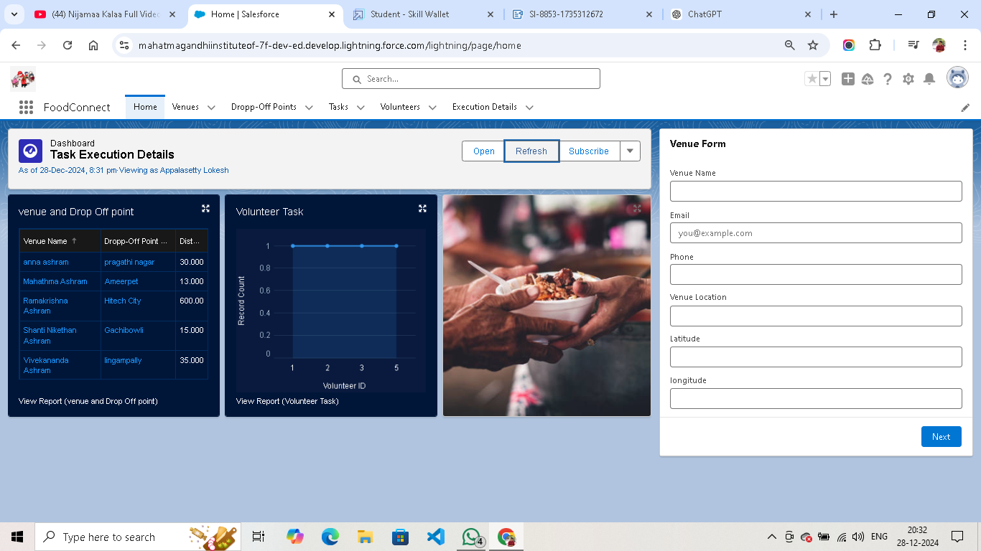

* **Einstein Analytics**: Use AI-powered analytics for predictive features, such as forecasting food donations or identifying areas with high deman

**5. Testing and Validation**

Before the app goes live, ensure comprehensive testing and deployment plans:

* **Unit Testing**: Write tests for all Apex classes and triggers.
* **User Acceptance Testing (UAT)**: Involve real users to ensure the solution meets their needs.
* **Performance Testing**: Make sure the app can handle the expected load, especially if the app will scale to thousands of users.
* **Deployment**: Use Salesforce Change Sets or Salesforce DX for deploying the app across different environments (Dev, Test, Production).

**6. Key Scenarios Addressed by Salesforce in the Implementation Project**

**1.**  **Food Donation Matching:**

* **Scenario**: A donor wants to give away surplus food, and a recipient (such as a food bank, charity, or individual) needs food.
* **Salesforce Solution**:
  + **Custom Objects & Relationships**: Use custom objects like Food Donation and Food Request to track donations and requests. Implement a relationship between these objects to allow food donations to be matched to available requests.
  + **Apex & Process Builder**: Automate the matching process using custom Apex triggers or Process Builder. For example, when a donation is logged, an automatic process can match it to an existing request with similar food types and quantities.
  + **Lightning Components**: Provide an easy-to-use interface for donors to enter donation details and recipients to submit requests.

**2. Real-Time Notification System**

* **Scenario**: Donors, recipients, and volunteers need to be alerted in real time about new donations, food requests, or the status of their donation (e.g., delivered, pending).
* **Salesforce Solution**:
  + **Email Alerts & Push Notifications**: Use Process Builder or Flow Builder to send automatic email notifications when new donations or requests are available, or when a food donation has been matched and is ready for delivery.
  + **Salesforce Mobile App**: Leverage Salesforce's mobile capabilities to send push notifications, keeping users informed in real-time even when they are on the go.

**3. Volunteer Management and Task Assignment**

* **Scenario**: Volunteers need to be managed and assigned tasks such as food pickup, sorting, or delivery.
* **Salesforce Solution**:
  + **Volunteer Profiles**: Create custom objects for Volunteer Profiles to store information about each volunteer, including their availability, preferred tasks, and areas served.
  + **Task Management**: Use Salesforce Tasks & Events to assign specific tasks to volunteers (e.g., picking up food, delivering it, or helping with sorting). Automatically assign tasks using Process Builde**r** based on volunteer availability and location.
  + **Volunteer Dashboard**: Build a custom Volunteer Dashboard to provide real-time updates on upcoming tasks, completed tasks, and hours worked.

**4. Recipient Profile and Tracking**

* **Scenario**: Track recipients of food donations and monitor their requests and the food they receive.
* **Salesforce Solution**:
  + **Recipient Profiles**: Create a custom Recipient Profile to track personal details, food preferences, dietary restrictions, past requests, and the amount of food they have received.
  + **Food Request & Delivery History**: Record the details of each food request and the history of food donations delivered to a recipient. This can be done by creating a related list for Food Requests and Food Deliveries within the recipient profile.
  + **Reporting & Analytics**: Use Salesforce’s Reports & Dashboards to track food distribution patterns, understand recipient needs, and identify areas for improvement or increased focus.

**5. Analytics and Reporting**

* **Scenario**: The organization needs to track key metrics such as the amount of food donated, the number of active donors/recipients, volunteer engagement, and the success of the program.
* **Salesforce Solution**:
  + **Custom Reports**: Use Salesforce’s Report Builder to create reports that show metrics like total food donations, food requests fulfilled, volunteer participation, and inventory levels.
  + **Dashboards**: Create visual Dashboards for management to track KPIs (Key Performance Indicators), such as donation frequency, number of recipients served, and volunteer hours worked.
  + **Einstein Analytics**: For deeper insights, use Salesforce Einstein Analytics (or Tableau CRM) for predictive analytics, such as forecasting demand for specific types of food based on past trends.

**Conclusions:**

The **Food Connect App** is designed to facilitate efficient food donation, distribution, and volunteer management, addressing the growing need for food security, reducing waste, and fostering community engagement. By leveraging Salesforce’s powerful platform, the app provides a comprehensive and scalable solution to streamline the process, connecting donors, recipients, and volunteers in a seamless manner.

Key conclusions include:

1. **Impactful and Sustainable Solution**: The app successfully connects food donors with recipients in need, creating a sustainable ecosystem for food distribution. It minimizes food waste and helps address food insecurity, especially in underserved communities.
2. **Streamlined Operations with Automation**: Salesforce’s automation tools, such as **Apex**, **Process Builder**, and **Flow Builder**, ensure that the donation and request process is efficient. These features help match donations with recipients, automate notifications, and track food inventory, reducing manual intervention and errors.
3. **Scalability and Flexibility**: The app is built on Salesforce’s cloud platform, which enables it to scale as the program grows. Whether expanding to new regions, incorporating more users, or adding new features, Salesforce provides the flexibility to adapt to future needs.
4. **Enhanced Volunteer and Recipient Engagement**: By creating detailed Volunteer and Recipient Profiles, the app allows for targeted support, personalized engagement, and optimized task assignments. Volunteers can be easily coordinated, and recipients can have tailored food offerings based on their preferences or needs.
5. **Real-Time Tracking and Transparency**: With the integration of Salesforce Maps and custom geolocation features, the app ensures that food deliveries are managed effectively, optimizing routes and ensuring transparency throughout the distribution process.
6. **Insights and Reporting**: Salesforce’s reporting and **Einstein Analytics** features allow the organization to gain valuable insights into donation trends, volunteer participation, and food distribution patterns. These insights drive informed decision-making and help improve the effectiveness of the program.